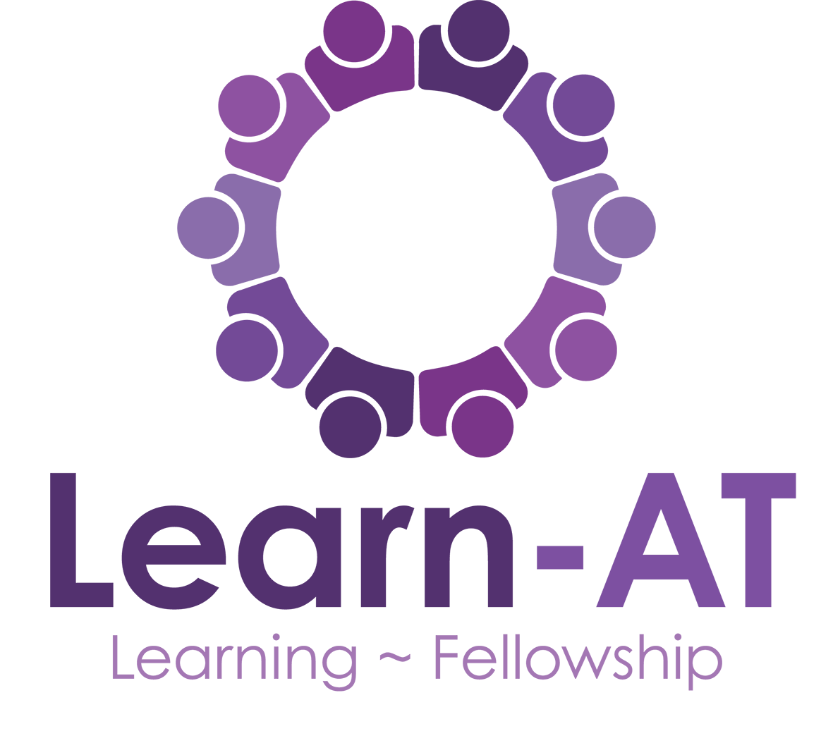

Learn-AT Curriculum and Pedagogy Framework
2019/20

Introduction
The Learn-AT Curriculum Framework is a work in progress. The Trust convened a working group (the Curriculum and Pedagogy Group - CPG) to investigate primary curriculum design during 2017/18. This document represents the CPG’s work since then and outlines the Learn-AT vision for a research -informed, coherent curriculum founded on shared values and principles. Our intention is to provide clear guidance for Learn-AT schools which will ensure equity and excellence. The framework provides a common curriculum design template from which schools can plan coherent sequences of learning to meet the needs of their pupils, secure deep learning and introduce them to knowledge beyond their experience. This collaborative project is now in its third year. During Phase One (2017/18), CPG engaged with a wide range of curriculum research literature, considered vision and principles and set the curriculum approach within a pedagogical context. Phase Two in 2018/19, saw CPG members and Learn-AT subject leaders working together to develop curriculum maps for each subject within eight primary curriculum domains (Alexander 2009). Phase Three, this year, involves curriculum leaders in schools, working together, sharing subject specialist and curriculum design expertise, to develop precise, detailed and coherent programmes of study for each curriculum subject. This year, too, CPG has shifted it focus from KS1 and KS2, to consider the principles of curriculum design in EYFS.
Curriculum and Cutlery
We began the project with a strong conviction that we wanted to develop a curriculum for our pupils which was rich, rounded and rigorous – like a rich minestrone soup, full of food for the intellect and food for the soul. Reading, writing and maths as the essential ‘cutlery’ needed by pupils to access the curriculum completed the metaphor. As the work of CPG has progressed, the soup has transformed from unstructured pottage into a dish that more resembles a lasagne – more carefully planned, with a coherent structure, layers and carefully-planned cross curricular links, vertical – through subject and years, horizontal between subjects within years and diagonal, between subjects in one year and different subjects in another.
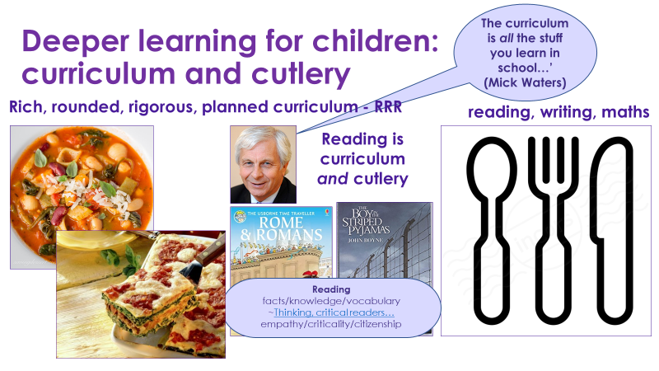
The Fundamental Importance of Reading
Reading is fundamentally important. Reading is both curriculum and cutlery. We expect all leaders and teachers to implement a research-informed approach to the teaching of reading. All schools implement a programme of systematic synthetic phonics, with fidelity, to teach early reading. Reading for pleasure pedagogies are employed to promote a school-wide reading culture and a love of reading for all pupils (https://researchrichpedagogies.org/research/theme/reading-for-pleasure-pedagogy).
This diagram summarises the key elements of the reading curriculum in Learn-AT schools:

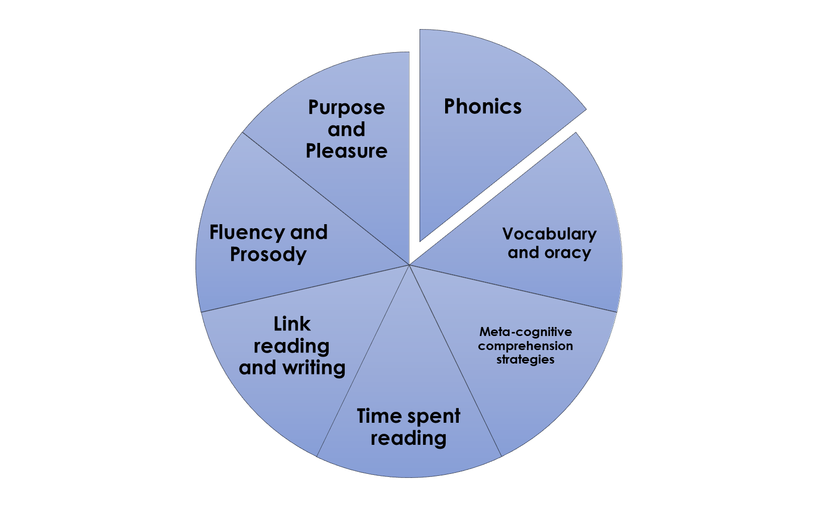

The Process of Curriculum Design
Three members of CPG participated in Whole Education’s Leading and Managing Curriculum Change project. This provided support and facilitation for the group’s curriculum design work. At the beginning of the project, Mick Waters provided an organisational structure for the curriculum design process as follows:
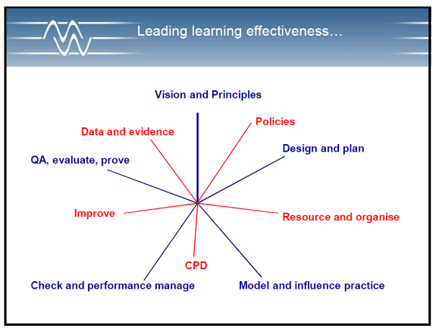
We developed a shared vision and agreed underpinning principles. This document represents the policy so far. The project has been implemented in four phases:
- 2017/18 - Phase 1: Research and reading, leading to the development of an overarching framework of curriculum design and pedagogical principles
- 2018/19 - Phase 2: Develop framework principles for each curriculum subject
- 2019/20 – Phase 3: work collaboratively with curriculum and subject leads across the trust to agree precise, detailed and coherent programmes of study, and sequences of learning for each subject contextualised to each school’s context. This is our curriculum intent. Review the Learn-AT Assessment Framework to secure high-quality assessment in all subjects and to ensure effective evaluation of the impact of our curriculum implementation.
- 2020 onwards – Phase 4: Develop high quality, subject-specific professional learning and development for teachers
We are working to achieve the effective implementation of a research-informed, rich, rounded, rigorous and coherent curriculum, developed through professional collaboration and which achieves our mission and aims for the benefit of all Learn-AT pupils.

Curriculum Literature
Members of CPG have read and discussed and wide range of curriculum and pedagogy-related literature, including the following authors:
Academics, policy-makers, writers and researchers:
Professor Michael Young; Andreas Schleicher; Daisy Christodoulou; E. D Hirsch; Dylan Wiliam; Michael Fullan and Joanne Quinn; Ron Berger; Professor Robin Alexander; Daniel Willingham; Kirschner, Sweller and Clark; Sfard; Didau and Rose; Curran and Gilbert; Lucy Crehan; Mary Myatt
Bloggers:
Christine Counsell; Clare Sealy; Jon Brunskill; Daniel Willingham; Doug Lemov; Rob Carpenter; Mary Myatt
In addition to taking part in the Whole Education LMCC project, we have visited and trawled the websites of schools both praised by Ofsted and recommended by Whole Education for their curricula. We have made use of the resources provided by the Core Knowledge Foundation and the Cambridge Primary Curriculum Review.
A Selection of CPG Curriculum Reading
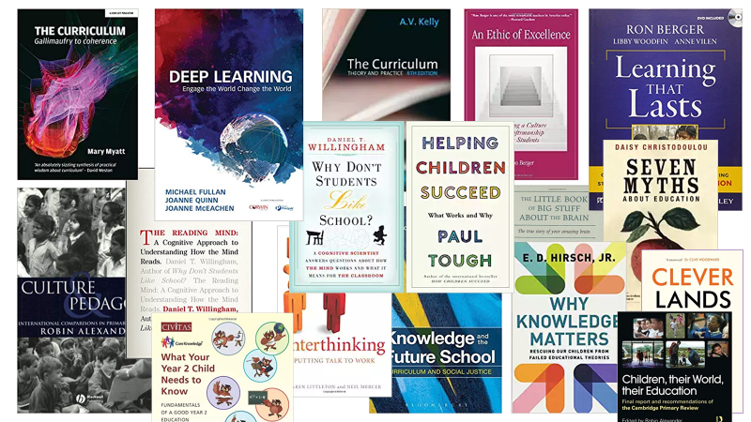

This Big Picture of the Learn-AT Curriculum is a key outcome of our learning and discussions:
Learn-AT Curriculum – Big Picture
What are we trying to achieve?
Mission | Every child flourishes and enjoys learning with access to a rich, rounded, rigorous and coherent curriculum
Aims | Successful, engaged learners who enjoy learning and who are knowledgeable and skilled, make progress and achieve | Confident, articulate individuals, who can lead safe, healthy and fulfilling lives |  | Responsible citizens who can make a positive contribution to society
Core trust values | Learning and fellowship
Intrinsic values | Christian values, British values and all those essential values common to good, kind and tolerant people of all faiths and no faith
RRR: a rich, rounded and rigorous curriculum | Core knowledge and understanding  e.g. excellent general, subject, social and cultural knowledge, | Skills and competences  Essential skills: literacy, numeracy, ICT, personal, social, emotional, learning and thinking skills, physical, moral, spiritual  The six cs: see below | Attitudes, attributes and dispositions  e.g. determined, adaptable, confident, risk-taking, enterprising, self-regulating, emotionally resilient, spiritually aware, tolerant, kind
What does the curriculum contain?
Mastery of Core Skills and Domain Knowledge | Domain Knowledge  Cultural  Subject knowledge (Curriculum)  General |  |  | Vocabulary  Tier 1  Tier 2  Tier 3  for reading and listening comprehension, written communication and oracy |  |  |  | Reading  - Volume  - Criticality  - Comprehension  - Curriculum content – fiction and non-fiction  Reading is an essential skill that also supports the acquisition of vocabulary and knowledge |  | Domain specific skills e.g. Music,  Computing,  Design  PE and Sport  etc |  |  |  | Fluency in basic skills  Maths: number - facts/operations  Cursive handwriting, phonics for spelling, grammar, technical accuracy  Decoding for reading – PHONICS  Social skills
Domains of Learning EYFS/KS1/KS2 | Faith and Belief | Mathematics |  |  | Science and Technology |  | Citizenship and Ethics |  | Place and Time |  | Arts and Creativity |  | Language, Oracy and Literacy |  |  | Physical and Emotional Health
Deeper Learning -  core competencies | Critical thinking and problem-solving |  | Communication |  |  | Creativity and imagination |  |  | Character Education |  |  | Citizenship |  |  | Collaboration
Foundational and universal competency | Oracy
Bottom line | Unconditional positive regard and well-being

How do we organise learning?
The curriculum as the entire planned learning experience, underpinned by the schools core values and mission
Components | Environment | Events | Extended hours | Learning outside the classroom | Lessons | Locations | Routines | Ethos

How is the curriculum delivered?
Pedagogical approaches to teaching and learning | Equity | Evidence | Engagement
 | - Equity and equality of opportunity, entitlement and experience  - Consistently high expectations, quality and standards for all Learn-AT pupils  - A mastery curriculum  - Excellence in SEND provision | Research-informed pedagogies:  - Formative assessment strategies embedded in teaching and learning  - Use of evidence from cognitive science research – e.g. importance of metacognition and self-regulation  - Balance of direct instruction and inquiry  - Strong self-evaluation | - Authentic purposes and contexts for learning – Berger 2006  - Emphasis on first-hand experience  - Purposeful, structured play in the early years; drama, strong emphasis on outdoor learning, sport and the Arts.  - Pupil agency, autonomy and choice  - Cross-curricular connections

How well are we doing?
Securing effective learning and teaching so that learners understand quality and how to improve
Evaluating Impact | Looks at the whole child, e.g. progress in knowledge, understanding and skills, attitudes, attributes and dispositions. | Uses assessment information intelligently to identify trends and clear goals for improvement |  | Uses critical friends to offer insights and challenges. |  | Uses a wide range of measures – qualitative and quantitative |  | Creates a continuous improvement cycle |  | Uses a variety of techniques to collect and analyse information |  | Employs principled, effective formative and summative assessment |  | Involves the whole school community: learners, parents, teachers, employers and governors.
to secure
Accountability measures | High standards of achievement – attainment and progress. |  | Good behaviour and attendance |  |  |  | Civic participation |  | Healthy lifestyles |  |  |  | Sustained involvement in education
and
Aims | Successful, engaged learners  who are knowledgeable, skilled, enjoy learning, make progress and achieve |  |  |  | Confident, articulate individuals  who can lead safe, healthy and fulfilling lives |  |  |  |  |  | Responsible citizens  who make a positive contribution to society

This slide illustrates the complex strands which weave together to create a rich, rigorous and coherent curriculum that prepares children for grown-up-ness (Biesta 2017):

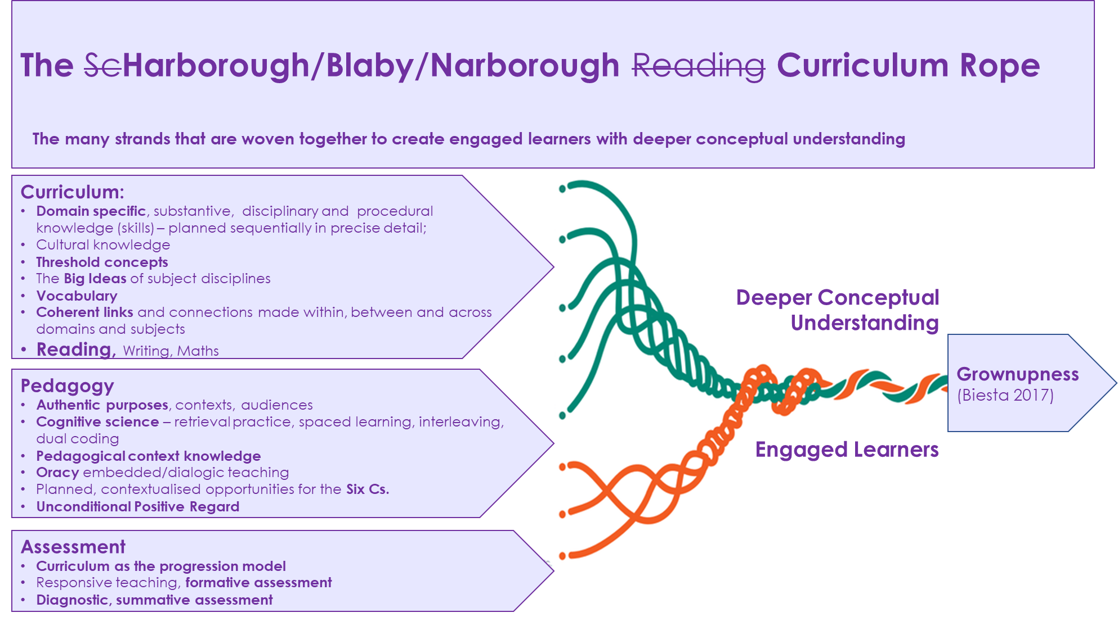
The Mission
Every child flourishes with access to a rich, rounded, rigorous and well-planned curriculum.
Aims
- Successful, engaged learners who are knowledgeable, skilled, enjoy learning, make progress and achieve
- Confident, articulate individuals who can lead safe, healthy and fulfilling lives
- Responsible citizens who make a positive contribution to society
Under-pinned by values
The Learn-AT core purpose of Learning and core value of Fellowship
and
values taken from Christian, Humanist and British cultural traditions:

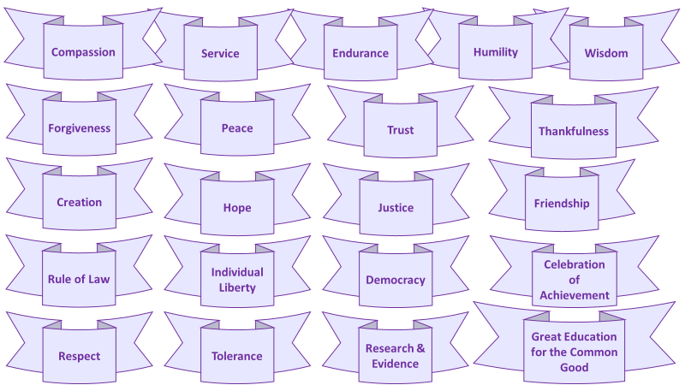

Curriculum and Pedagogy

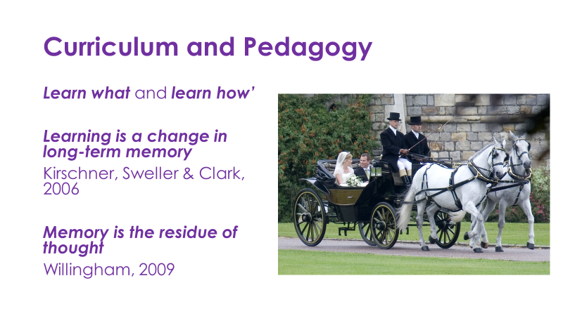

During our deliberations, we have found it impossible to divorce consideration of curriculum from discussion of pedagogy. Dylan Wiliam says that curriculum at the achieved level is pedagogy (2016). They are intrinsically linked. Learning can be defined as a change in the long-term memory and memory as the residue of thought (Sweller et al, 2006; Willingham, 2009). This means that we must design a curriculum that provides pupils with comprehensive and foundational knowledge but ensure that it is taught in such a way that secures that knowledge in long-term memory. In this way it can be used to support the development of skills, built on and applied later. To do that we need to make sure pupils think deeply about their learning. Superficial curriculum ‘delivery’ is not enough. Our pupils deserve deep learning.

This poster summarises and synthesises some recent research relating to the nature of learning (McRea, Caviglioli 2018):
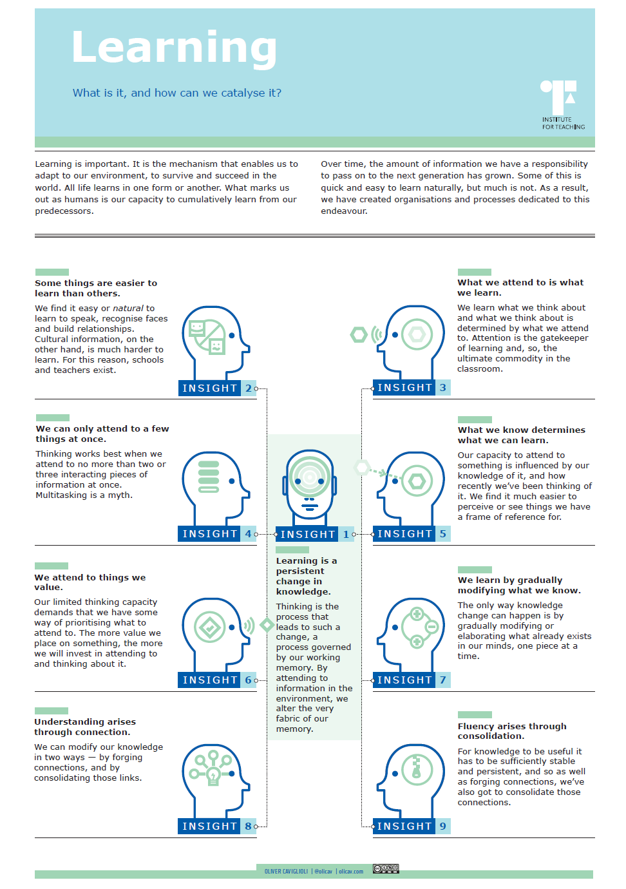

Mick Waters uses this diagram to illustrate the ways in which teachers can use pedagogy to teach the curriculum:
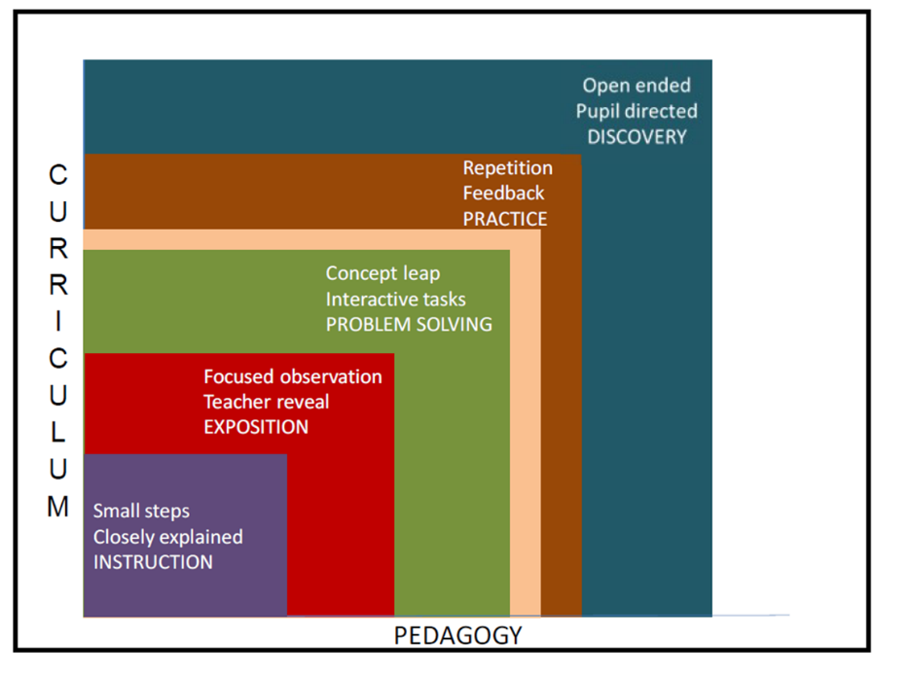
He suggests that the pedagogical cycle involves explicit teaching of an element of knowledge, or a key concept, and develops conceptual understanding and/or deep learning through a process of explicit instruction, exposition, problem-solving, deliberate practice and inquiry.
Doug Lemov (2016) explains that Bloom’s Taxonomy is often misinterpreted – that Bloom placed knowledge and remembering facts at the base of his pyramid to indicate its essential place as the foundation required for the other elements to be possible. He suggests that Bloom’s Taxonomy can be re-imagined as a vehicle for facilitating deeper learning:
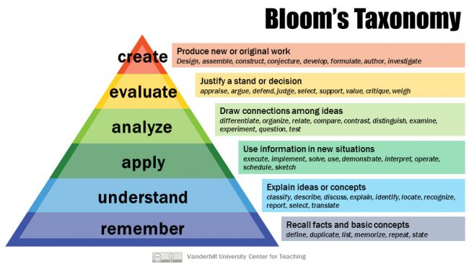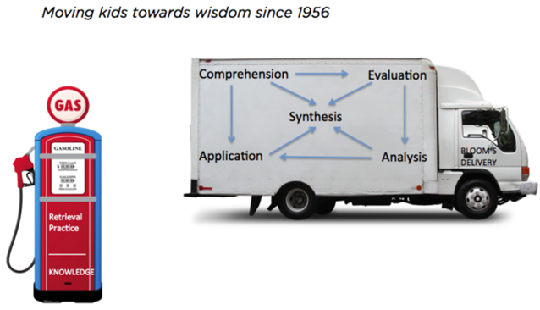
The Learn-AT curriculum emphasises the essential place of knowledge in learning and its important role in supporting the development of domain-specific skills, competencies and non-cognitive capacities such as attitudes, attributes and dispositions. The curriculum therefore has three key and interwoven strands:
- Core knowledge and understanding
- Skills and competencies
- Attitudes, attributes and dispositions
We consider core knowledge to include:
- Excellent general, domain and subject knowledge
- Social, moral and cultural knowledge
- Broad vocabulary to support rich understanding and cognitive schema
- Big ideas that shape the world
Core skills and competencies include:
- Skills such as literacy, numeracy, digital, personal, social, emotional, learning and thinking skills, meta-cognition, physical, moral, spiritual…
- The Six C’s – competencies for deeper learning:
- Critical thinking and problem solving
- Communication
- Creativity and imagination
- Character Education
- Citizenship
- Collaboration
We value highly the development of non-cognitive capacities such as:
- Determination
- Adaptability
- Flexibility
- Confidence
- Risk-taking
- Enterprise
- Self-regulation
- Emotional resilience
- Spiritual awareness
- Tolerance
- Kindness
- Curiosity
We believe these are most effectively developed within the context of a rich, rounded and rigorous, coherent curriculum, rather than taught discretely or in isolation (Tough, 2016).
Organisation of Learning
Mick Waters defines the curriculum as ‘all the stuff you learn in school’. Organising something so all-encompassing is complex and involves many inter-relationships.
This diagram acknowledges the influence of school culture and ethos on all aspects of school life and illustrates the ways in which the primary curriculum is organised:
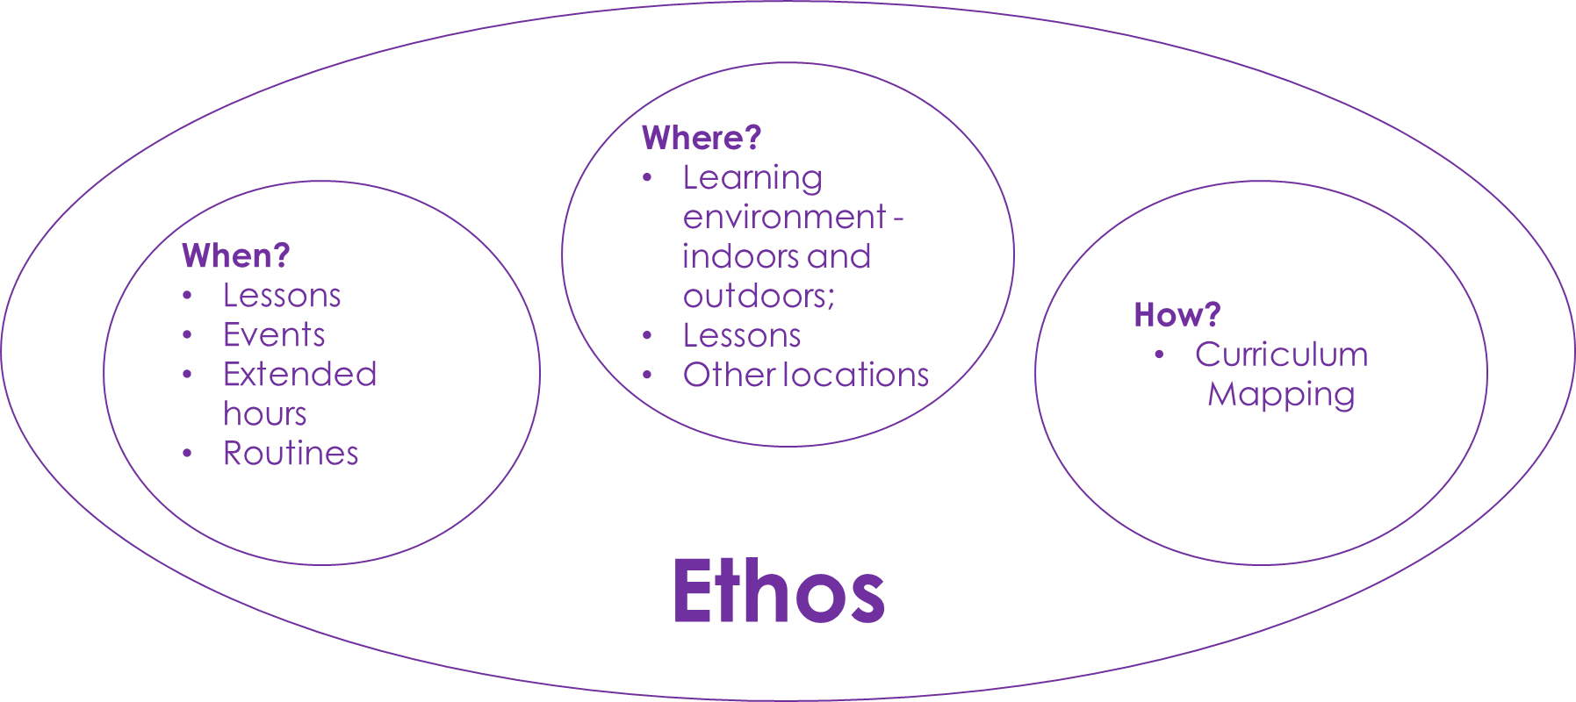

Equity
We are committed to equity and equality of opportunity, entitlement and experience for all pupils, regardless of their social or cultural background, race, ethnicity, religion, gender or ability. In the context of curriculum and pedagogy this means:
- We have consistently high expectations and set high standards for all pupils. All pupils will experience challenge, regardless of their ability or prior attainment.
- We are committed to a ‘Mastery’ approach to curriculum and pedagogy. This means we do not discriminate on grounds of prior attainment or ability. We intervene to provide additional support or teaching and learning time so that every child can achieve and make good progress. We teach key concepts to mastery and provide opportunities for learners to achieve deeper understanding. By integrating the 6C’s and Bloom’s Taxonomy (re-interpreted with knowledge as the foundation; see Appendix 6), teachers support children of all abilities to secure and consolidate their foundational knowledge and deepen their learning.
- We are committed to excellence in provision for pupils with SEND. We expect them to make good progress from their starting points. We provide a high-quality curriculum that meets their specific learning needs and promotes their well-being.
Evidence
The Learn-AT curriculum is research evidence-informed. Its emphasis on knowledge derives from research in cognitive science. In addition, we are committed to implementing research-informed pedagogies such as:
- Formative assessment strategies embedded in teaching and learning
- Development of metacognition and self-regulation
- Balance of direct and guided instruction and inquiry learning – recognising that inquiry-learning requires secure domain knowledge
- Use of assessment and evidence to evaluate impact of teaching on learning.
Engagement
Because we want pupils to remember what we teach, we want them to think about their learning. Thinking requires authentic engagement. We use a range of strategies to promote deeper learning and engagement:
- Integration of the 6Cs in all aspects of the curriculum (Fullan, Quinn 2018)
- Authentic purposes and contexts for learning (Berger 2006)
- Emphasis on first-hand experience and curricular enrichment following foundational knowledge development
- Purposeful, structured play in the early years; drama, strong emphasis on outdoor learning (e.g. Forest School), PE, sport and the Arts.
- Pupil agency, autonomy, choice and voice
- Strong, coherent cross-curricular connections

Faculties, Domains and Subjects
The Cambridge Primary Curriculum Review (Alexander, 2009) organises subjects into eight domains of learning:
- Language, Oracy and Literacy
- Mathematics
- Science and Technology
- Place and Time
- Arts and Creativity
- Physical and emotional health
- Faith and Belief
- Citizenship and Ethics
For organisational purposes we have organised those domains into four faculties:
Faculty | Domain | Subject
STEM | Mathematics | Mathematics
 |  | Science
 | Science and Technology | Design
 |  | Computing
Arts | Language, Oracy and Literacy | English
 |  | Languages
 | Arts and Creativity | Art
 |  | Music
 |  | Drama
Wellbeing | Citizenship and Ethics | PSHE/SRE
 |  | Philosophy
 | Physical and Emotional Health | PE
 |  | Sport/Outdoor Education/Forest School
Humanities | Place and Time | Geography
 |  | History
 | Faith and Belief | RE
 |  | Philosophy

A mastery approach to learning
In the same way that we want our pupils to learn and to remember what they are taught, we want them to develop automaticity and fluency in core skills. Research evidence suggests strongly that fluency in skills such as phonics for reading and writing, cursive handwriting, automatic recall of basic number facts, spellings and technical aspects of writing such as punctuation reduces the cognitive load and frees up cognitive space for further learning. Fluent writing can be a useful tool for thinking across the curriculum. Fluent reading combined with a broad vocabulary supports understanding across all domains. Reading and writing are the cutlery pupils need to access the curriculum throughout their education. Our aim is for all pupils to master these skills and the foundational knowledge they need to build age-appropriate expertise in each domain of learning.
This diagram illustrates the Mastery Learning Cycle for mathematics: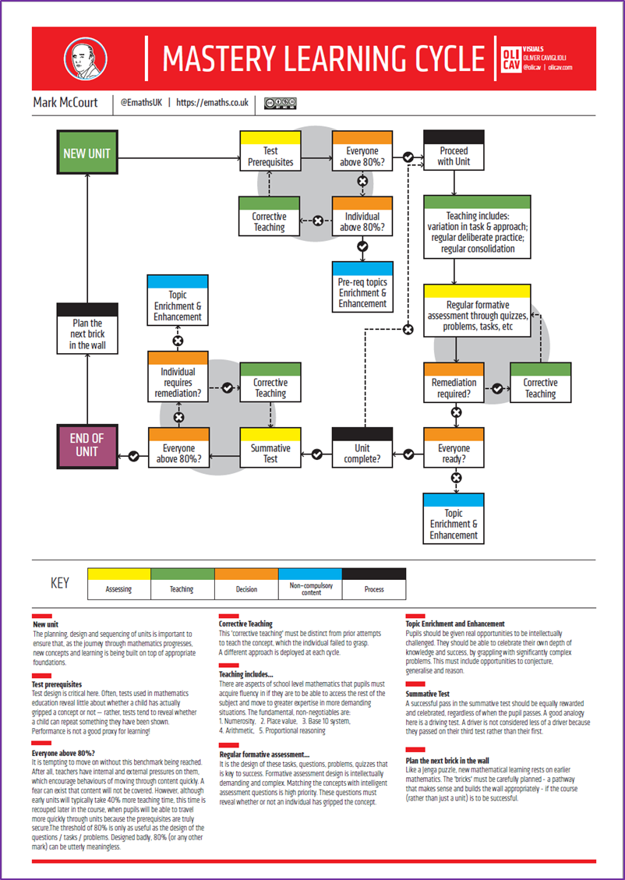
In addition to these core skills, teachers integrate the teaching of domain and subject specific skills such as:
- Music
- Computing
- Design
- PE/sport
- Map reading (Geography)
- Interpreting evidence from primary sources (History)
- Understanding the principles of fair testing (Science and Technology)
- and many more…
Vocabulary and Oracy
Vocabulary and oracy development have an essential role to play in addressing disadvantage. For all pupils, regardless of background, a broad vocabulary is essential to support comprehension of spoken language and complex texts (Willingham, 2017; Hirsch, 2016; Beck, McKeown, 2013; Quigley, 2018). We develop Tier 1, Tier 2, and Tier 3 vocabulary through explicit teaching, for example through Word Study, linked to the teaching of spelling, by explicit teaching of subject specific specialist vocabulary in context, by championing high-quality dialogue with all pupils, and by promoting a high volume of independent reading (Allington 2016). We want all children to read independently and at length every day, in school. This is particularly important for children from disadvantaged backgrounds who may not have the opportunity to do this at home.
Reading is an essential skill that unlocks doors to learning, builds vocabulary, domain, social and cultural knowledge and empathy; reading is key to social mobility. Research suggests that these aspects of a reading curriculum are significant:
- systematic synthetic phonics to support early decoding fluency
- Volume of reading
- Oral language and vocabulary
- Criticality
- The development of metacognitive comprehension strategies
- Links to wider curriculum content – fiction and non-fiction
- Strong links to the teaching of writing
Oracy
If reading is key, oracy is central. Without fluency in spoken language and the ability to understand fluent spoken language, children will struggle to achieve in school and in life.
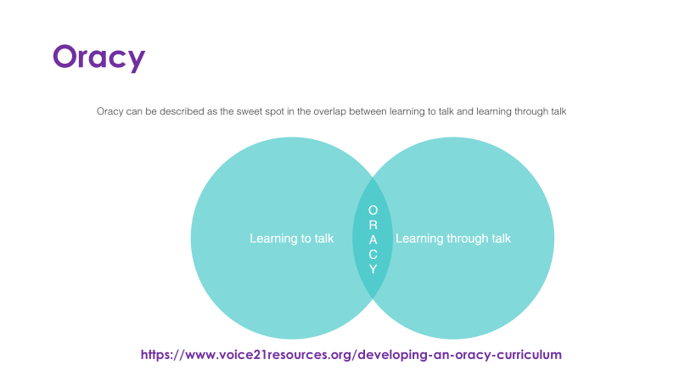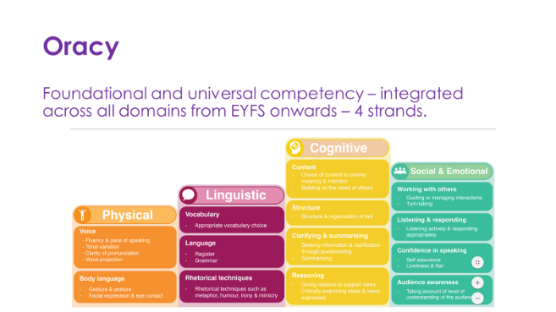
The Learn-AT curriculum puts a strong emphasis on the integration of opportunities to develop oracy skills across all domains of learning.

The Six C’s
Often described as 21st Century skills, at Learn-AT we don’t think the 6 C’s are any more pertinent to the 21st century than all the others. We think these skills are universal and essential for human innovation and creativity. However, we think they should be developed in domain contexts, integrated across the curriculum and build on foundational knowledge, as tools for developing profound engagement and deeper learning.
‘Deep learning is valuable learning that sticks…is good for all, but it is especially powerful for those most alienated from the traditional schooling system’ (Fullan et al, 2018, p.xvii)
‘The crucial discriminator of deep learning is the depth of acquisition of the new competencies’
‘The movement toward increasingly complex acquisition of the 6 Cs must be the anchor that drives the learning design and what makes the learning deep.’ (Fullan et al, 2018, p69)
The Six Cs are:
Character
- Learning to learn
- Grit, tenacity, perseverance and resilience
- Self-regulation, responsibility and integrity
Citizenship
- Thinking like a global citizen
- Considering global issues based on deep understanding of diverse values and worldviews
- Genuine interest and ability to solve ambiguous and complex real-world problems that impact human and environmental sustainability
- Compassion, empathy and concern for others
Collaboration
- Working interdependently and synergistically in teams
- Interpersonal and team-related skills
- Social, emotional and intercultural skills
- Managing team dynamics and challenges
- Learning from and contributing to the learning of others
Communication
- Communicating effectively with a variety of styles, modes and tools including digital
- Communication designed for different audiences
- Reflection on and use of the process of learning to improve communication
Creativity
- Having an entrepreneurial eye for economic and social opportunities
- Asking the right inquiry questions
- Considering and pursuing novel ideas and solutions
- Leadership to turn ideas into action
Critical Thinking
- Evaluating information and arguments
- Making connections and identifying patterns
- Problem solving
- Constructing meaningful knowledge
- Experimenting, reflecting and acting on ideas in the real world
Ron Berger (2014) talks about deeper instruction and advocates the use of the ‘hierarchy of audience’ to provide authentic contexts for pupil engagement and deeper learning:
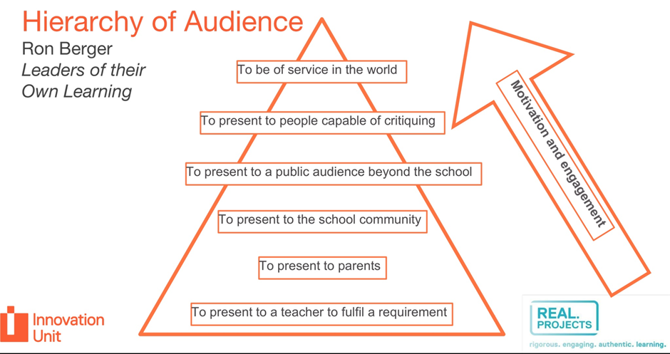
Mantle of the Expert (Heathcote, 1995; Taylor, 2016) and other drama techniques and strategies can also help teachers to provide engaging and authentic contexts for pupil learning.
Planning for Deep Learning
Teachers plan coherent sequences of lessons which lead to tangible outcomes over extended periods of time. Outcomes can be extended pieces of writing, including essays based on curricular topics in history and geography for example, extended pieces of narrative, expository or discursive writing in English, or presentations, speeches etc. Journalling is used in mathematics to support the development of reasoning, problem-solving and deep learning. Useful guidance on effective planning can be found here:
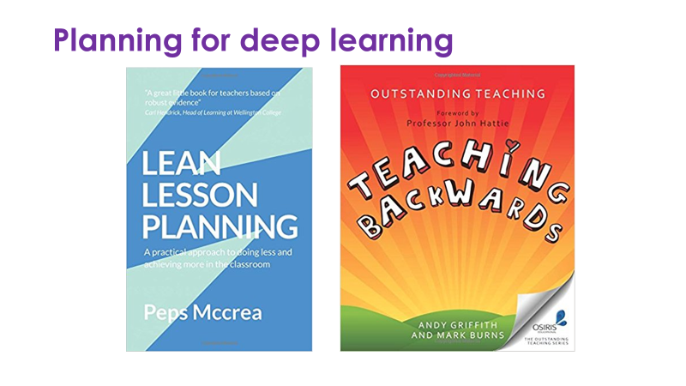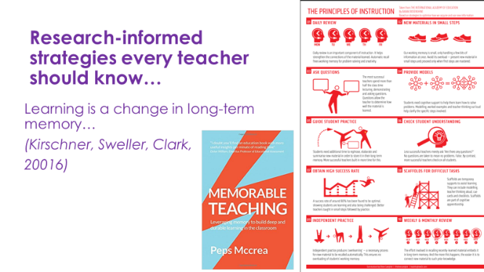

This poster summarises Barak Rosenshine’s Principles of Instruction:
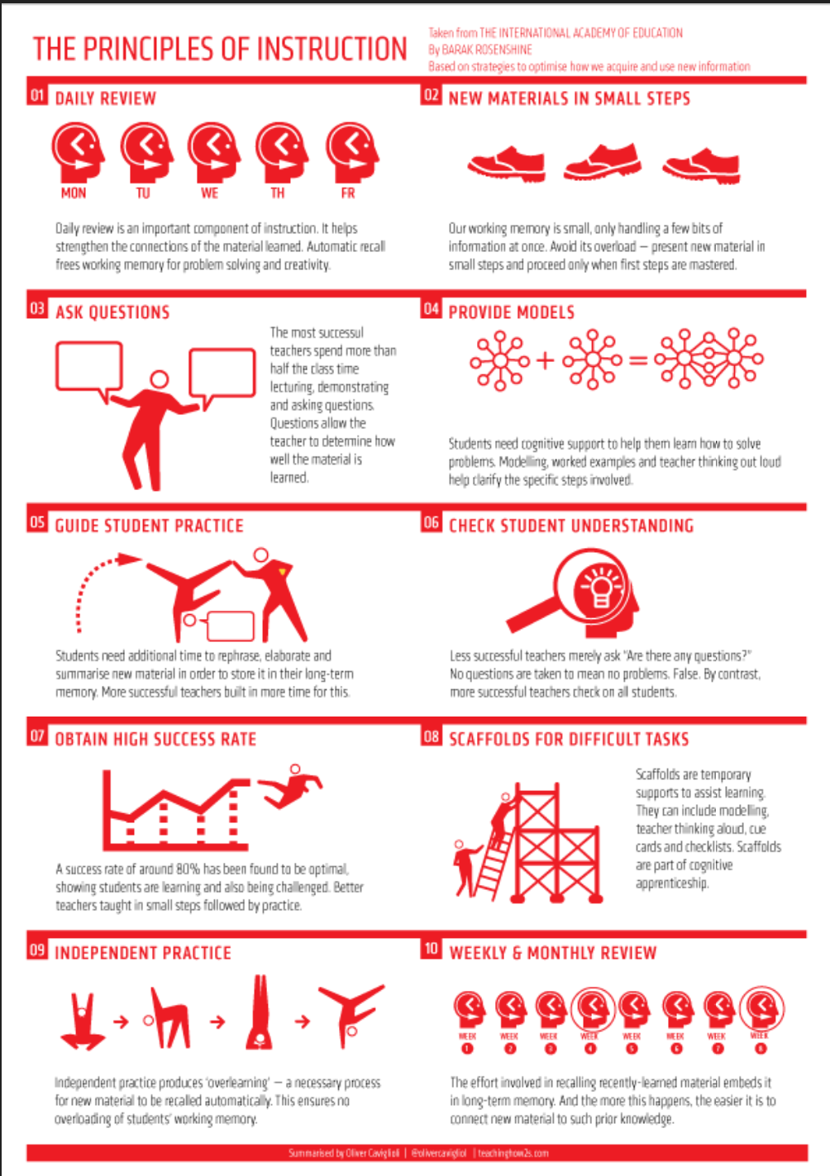
The Bottom Line – Unconditional Positive Regard
We treat every pupil, without exception, with unconditional positive regard. Practising unconditional positive regard means accepting and respecting others as they are without judgment or evaluation.
Learn-AT Curriculum Frameworks
Phase Two of this curriculum design work involved agreeing frameworks for each subject. CPG members and Learn-AT Subject Leaders worked together to develop a planning template to support curriculum and subject leaders to design precise, coherent and detailed sequences of learning for each subject during Phase Three. The subject frameworks indicate the big ideas, key concepts and vocabulary essential to coherent curriculum intent for each subject.
Framework documents and associated curriculum resources and guidance are stored in the Learn-AT Curriculum Framework Team on Microsoft Teams. Here is an example of the History Curriculum Framework:

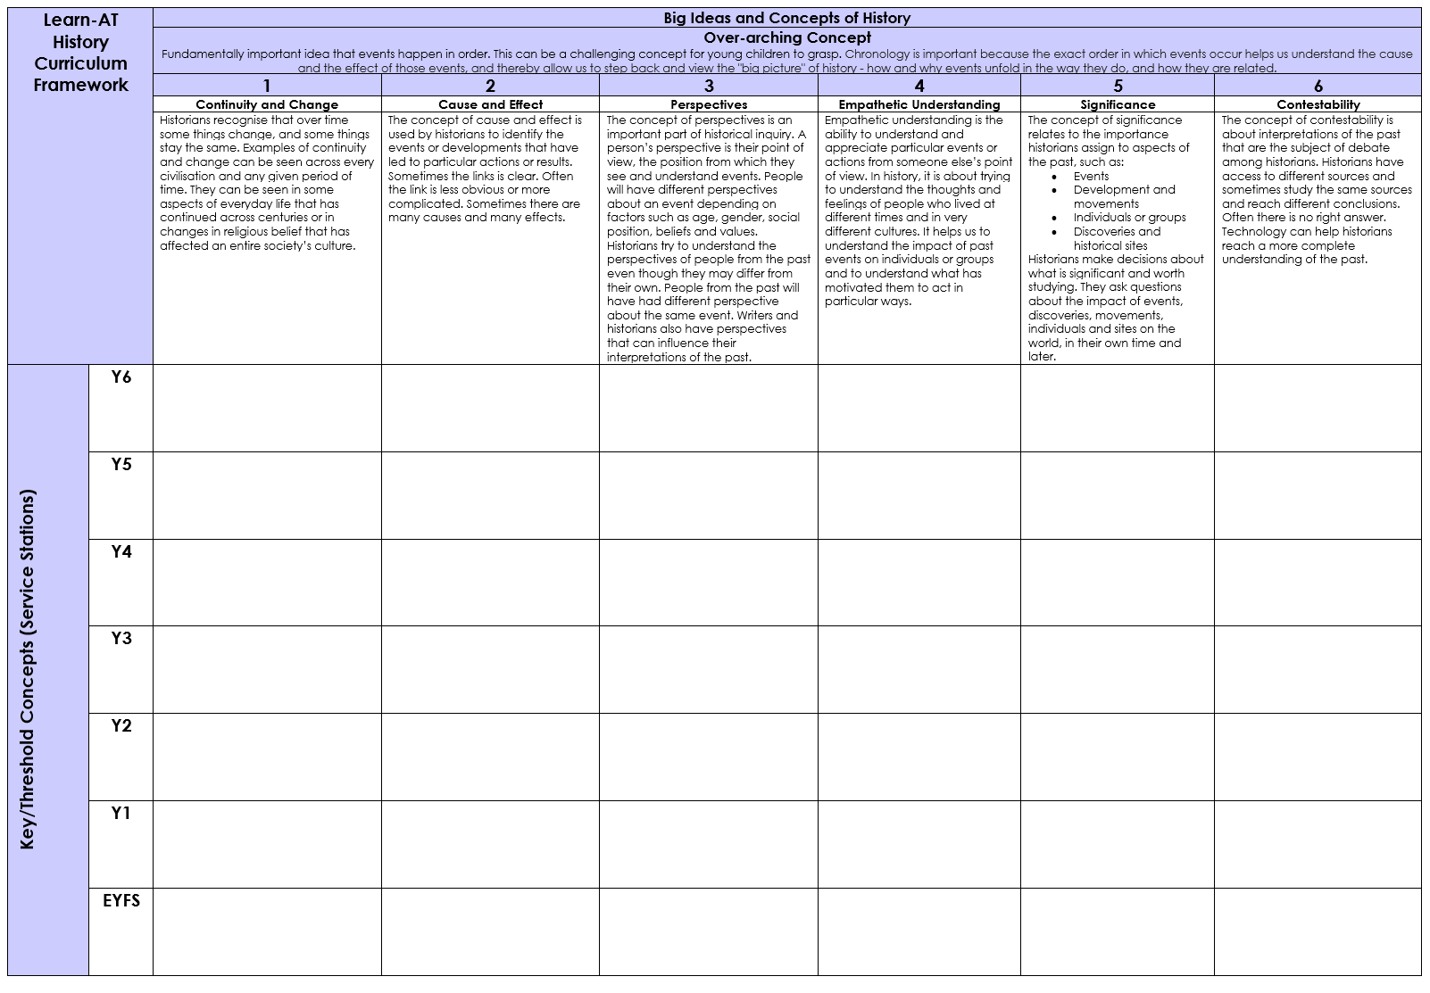

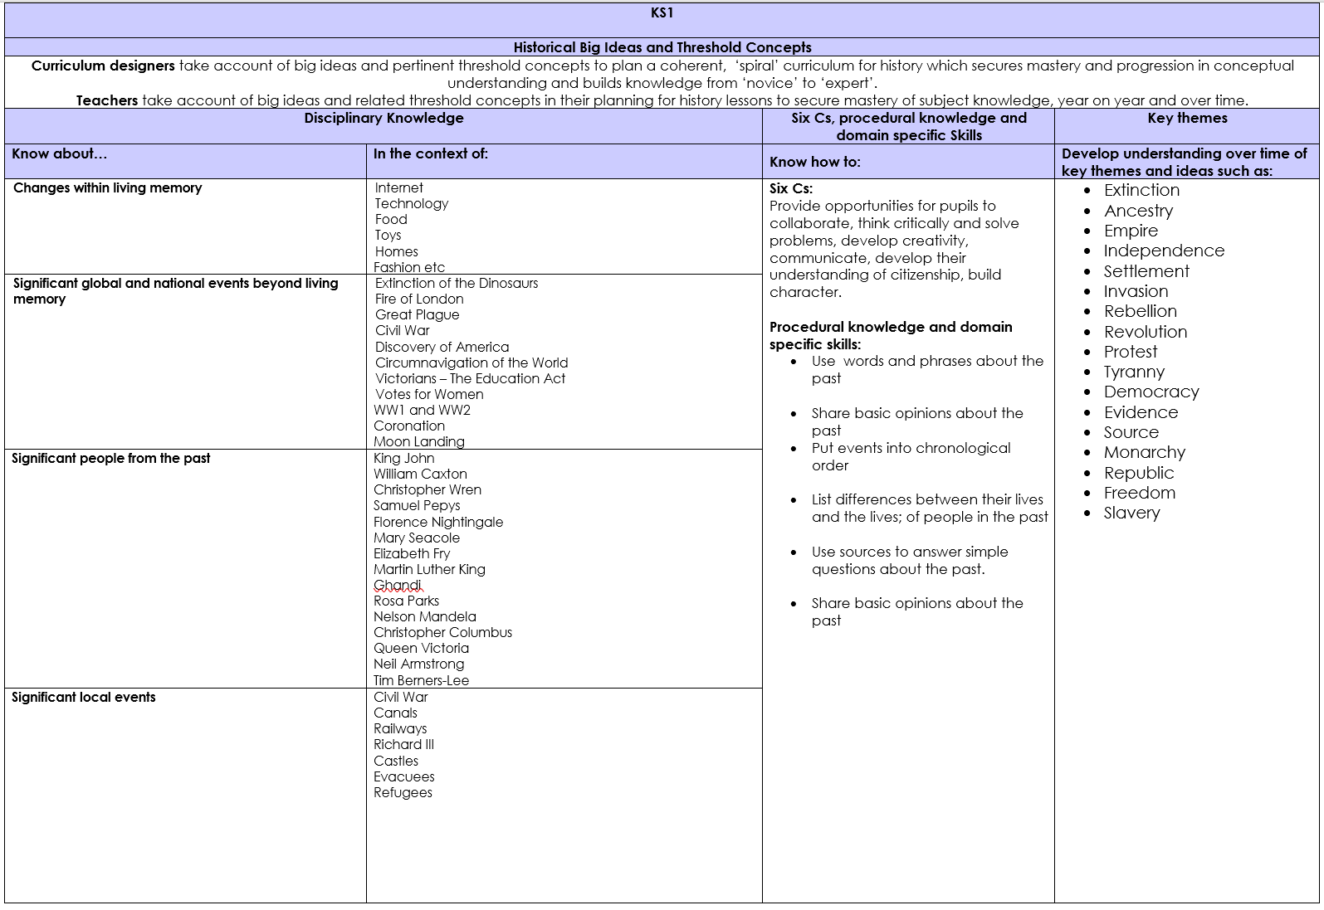
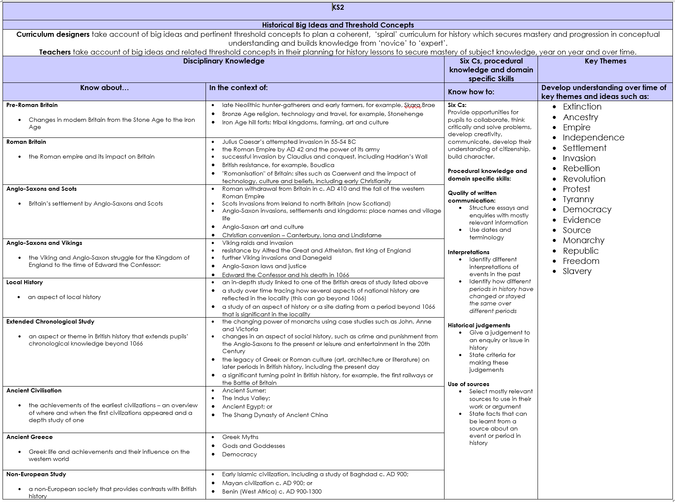

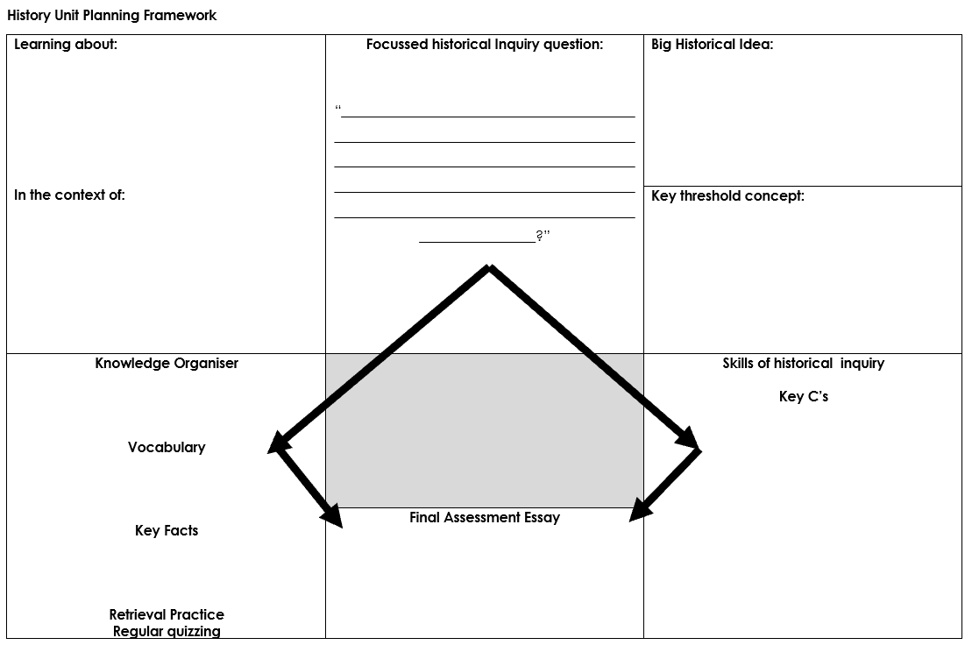
Knowledge Organisers
During Phase Three, teachers and curriculum leaders to develop an archive of Knowledge Organisers to support planning for mastery and assessment of key knowledge for foundation subject topics. Here are some examples of Knowledge Organisers:
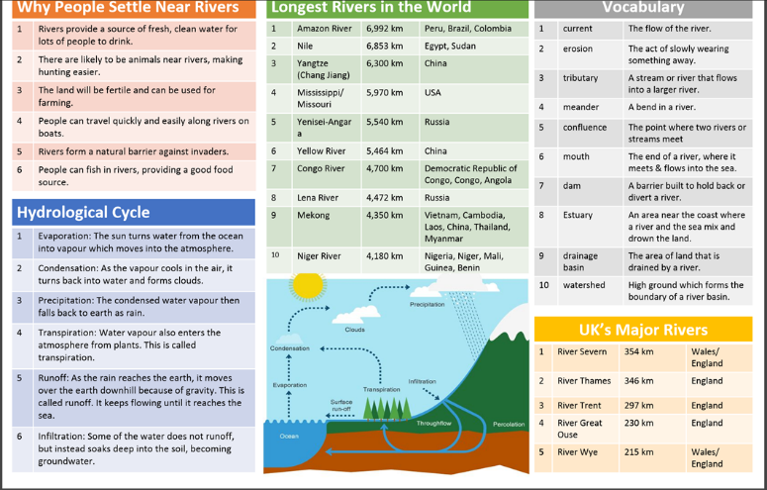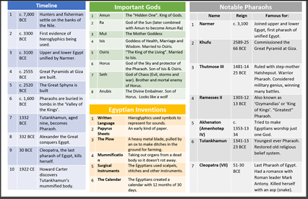
However, a knowledge organiser does not a curriculum make. It is essential that Knowledge Organisers are developed in a context of a coherent and carefully planned sequence of learning and implemented within a context of effective and research-informed pedagogy.

Monitoring and Evaluation
Strategies for evaluation of the quality of education and the impact of the curriculum:
- Look at the whole child, e.g. progress in knowledge, understanding and skills, attitudes, attributes and dispositions.
- Use assessment information intelligently to identify trends and clear goals for improvement
- Use critical friends to offer insights and challenges
- Use a wide range of measures – qualitative and quantitative
- Create a continuous improvement cycle (see Learn-AT School Improvement Framework)
- Use a variety of techniques to collect and analyse information
- Employ principled, effective formative and summative assessment (see Learn-AT Assessment Framework)
- Involve the whole school community: learners, parents, teachers, employers and governors.
Accountability measures relate to:
- High standards of achievement – attainment and progress – in all curriculum subjects.
- Good behaviour and attendance
- Civic participation
- Healthy lifestyles
- Sustained engagement in education
Appendix 1: Principles, Features and Rationale of the Learn-AT Curriculum and Pedagogy Framework
Principle | Feature | Rationale | What does this look like in practice?
Coherent, domain-specific skills development | - Strong emphasis on oracy, literacy and numeracy development.  - Securing early, fluent reading and writing is prioritised  - Subject specific skills taught in context.  - Six C’s integrated in all facets of the curriculum and developed in the context of curriculum domains.  - Emphasis on development of metacognition and self-regulation and other non-cognitive attributes e.g. resilience in curriculum domain contexts. | Mind in Society (Vygotsky 1978)  Words and Minds (Mercer 2000)  Interthinking (Littleton, Mercer 2013)  Deep Learning (Fullan, Quinn, McEachen 2018)  How to Build a World Class Education System (Schleicher 2018)  An Ethic of Excellence (Berger 2003)  Learning that Lasts (Berger 2016)  Handwriting in Early Childhood (Zaner-BLoser 2017)  Handbook of Writing Research (McArthur 2016)  Early Literacy Research (Reutzel 2015)  Exploring the relationship between letter recognition and handwriting in early literacy development (Reutzel et al 2017)  Writing Revolution: a guide to advancing thinking through writing across all subjects and grades (Hochman, Wexler 2017)  Early Reading Instruction (McGuinness 2006)  The Power of Reading: Insights from the Research (Krashen 2004)  What Really Matters When Working with Struggling Readers (Allington, 2013)  The Reading Mind (Willingham 2017)  Metacognition and Self-Regulation (EEF 2018)  Helping Children Succeed: What Works and Why (Tough, 2016)  Bloom’s Taxonomy Delivery Service (Lemov, 2017)  Webb’s Depth of Knowledge Continuum (Hess, 2013) | - Handwriting fluent and automatic, early.  - English front and centre in curriculum planning.  - High volume of independent reading and writing every day.  - Planning and provision for development of Six C’s integrated into all curriculum domains.  - Authentic purposes for learning and authentic audiences for curriculum products.  - Open-ended questions prompt thinking, conversation, dialogue and extended answers.  - Challenging work creates productive struggle.  - Opportunities for reasoning and problem solving are embedded into all subjects, especially mathematics.  - Secure knowledge is the foundation for the development of skills  - Generic skills are not taught in isolation  - Grammar is taught in the context of writing for authentic purposes and audiences.
Curriculum coherence | Teaching is planned over sequences of lessons towards clear overarching learning objectives and outcomes. | Teaching Backwards (Griffiths, 2014)  Lean Planning (McRea 2018)  Writing Revolution (Hochman, Wexler 2017) | - Sequences of learning are evident in pupils’ work.  - Coherent, incremental introduction of key concepts, knowledge and skills.  - Consistent, high expectations in literacy across the curriculum.  - Coherent links are made between subjects to support deeper learning, for example, foundation subject content in texts and writing topics in English and application of and attention paid to literacy skills in foundation subjects and writing is used as a tool for thinking in maths journaling.
Knowledge-rich | Knowledge organisers with key facts and vocabulary placed at the heart of curriculum topics. | Cultural Literacy (Hirsch 1984)  Why Knowledge Matters (Hirsch 2016)  Seven Myths of Education (Christodoulou, 2013)  What is a Curriculum and What Can it Do? (Young 2014)  On the Powers of Powerful Knowledge (Young, Muller 2013)  Knowledge and the Curriculum (Simons, Porter 2015)
Teaching for Mastery/Mastery Learning | Teachers adopt a mastery approach to teaching and learning in all subjects. | Closing Achievement Gaps: Revisiting Benjamin Bloom’s Learning for Mastery (Guskey 2007)  Mastery Learning Cycle: Mark McCourt 2018  Learning without Limits (Peacock, 2016)  Learning without Labels (Rowland, 2017)  Mastering Mathematics (Drury, 2014) | - Fewer topics are taught but in greater depth  - Rapid intervention ensures that children who need additional support catch up quickly  - Effective pre-teaching means all children can access the main lesson.  - Differentiation by support and intervention to secure understanding and achievement  - High expectations for all pupils regardless of prior attainment.  - All pupils without significant SEND are expected to achieve the expected standard or better at the end of each Key Stage.  - All pupils, including those with SEND, are expected to make good progress from their starting points.  - No grouping/setting by ability.
Retrieval practice:  regular quizzing and cumulative quizzing | Multiple choice quizzes linked to Knowledge Organisers | Ebbinghaus’s Forgetting Curve (1885)  Retrieval-Based Learning: the need for guided retrieval in elementary school children (Karpicke et al, 2014)  Memorable Teaching (McRea, 2017) | Pupils self-quiz using their Knowledge Organisers  - Lessons often start and end with MCQs  - Teachers ask a lot of closed questions linked to key facts.
Research-informed Pedagogies | Classroom practice, CPD and leadership support is guided by evidence from authoritative educational research. Practices such as those outlined in What Makes Great Teaching, (Coe et al, 2014) and Rosenshine’s principles of instruction are encouraged. | What Makes Great Teaching (Coe et al 2014)  Principles of Instruction (Rosenshine, 2012)  Why Minimally Guided Instruction Doesn’t Work (Kirschner et al 2016)  Educational Effectiveness State of the Art Review (Reynolds et al 2014)  The New Art and Science of Teaching (Marzano 2017)  Understanding how we learn (Weinstein, Sumeracki 2019)  Dual Coding for Teachers (Caviglioli, 2019) | - Lessons are teacher-led.  - New information in small chunks.  - Narrative often used to deliver information as a story.  - Frequent practice/oral rehearsal of key facts/concepts  - Models, images and scaffolds used to support learning.  - Where appropriate, the teacher guides further learning and consolidation in small groups.  - Inquiry learning builds on explicitly taught and secure foundational knowledge  - Pupils have regular opportunities for deliberate practice.
End of Unit Essay | Pupils write an extended essay at the end of each curricular topic. | Opportunity to organise knowledge learned in a sustained report or argument.  What Will Improve a Student’s Memory? (Willingham, 2008)  Essay writing skills development. | - Y1/2: Restate facts they have learned to inform reader about their topic  - Y3/4: Organise and group ideas into paragraphs to make a persuasive argument.  - Y5/6: Write a balanced discursive essay, referencing and assessing for and against each point.
Responsive teaching | Formative assessment is embedded in all lessons. | Embedded Formative Assessment (Wiliam, 2011)  Embedded Formative Assessment: Strategies (Wiliam 20  Making Good Progress (Christodoulou, 2016) | - Clear learning objectives and success criteria  - Effective questioning  - Low stakes assessment strategies  - High quality verbal feedback supports progress in learning
Enrichment | Curriculum is enriched through first-hand experiences. | Facilitates application, exploration and deepening of learning  Arousal Mediated Memories (LaBar, Phelps 1998)  Joy! | Visiting speakers, curriculum events, educational trips and visits are organised to enrich curriculum topics, usually towards the end of a topic so that children’s learning experience is enhanced by their increased knowledge, following topic teaching.
Authentic purposes for learning | Teachers integrate authentic purposes for learning to their unit planning. | An Ethic of Excellence (Berger, 2003)  Learning that Lasts (Berger, 2016); Leaders of their own Learning (Berger, 2014)  Deep Learning (Fullan and Quinn, 2018); Four Purposes for Writing (Tidd, Templar-Wilson, 2016)  Mantle of the Expert (Taylor 2017) | - using Michael Tidd’s four main purposes for writing;  - creating projects with genuine purposes in the local community or beyond;  using drama techniques like Mantle of the Expert to engage and motivate children in authentic learning contexts.

Appendix 2: Curriculum Overview 1
Faculty | Domain | Subject | Cycle 1* |  | Cycle 2 |  | Cycle 3 |  | Cycle 4
Arts | Language, Oracy and Literacy | English | Entertain  Inform  Persuade  Discuss |  | Inform  Persuade  Discuss  Entertain |  | Persuade  Discuss  Entertain  Inform |  | Discuss  Entertain  Inform  Persuade
 |  |  | Integrated grammar and word study/spelling – planned for progression
 |  |  | Handwriting - explicit, direct teaching and daily practice
 |  |  | Core Text  1 | Core Text 2 | Core Text  3 | Core Text  4 | Core Text  5 | Core Text  6 | Core Text 7 | Core Text 8
 | Arts and Creativity | Drama | Unit 1 |  |  |  | Unit 3
 |  | Art |  |  | Unit 1 |  |  |  | Unit 2
 |  | Music | Unit 1 |  |  |  | Unit 2
Humanities | Time and Place | Geography, History | Topic 1 History |  | Topic 2 Geography |  | Topic 3 History |  | Topic 4 Geography
 | Faith and Belief | RE | Unit 1 |  | Unit 2 |  | Unit 3 |  | Unit 4
STEM | Maths | Maths | Unit 1 |  | Unit 2 |  | Unit 3 |  | Unit 4
 | Science and Technology | Science | Unit 1 |  | Unit 2 |  | Unit 3 |  | Unit 4
 |  | Design |  |  | Unit 1 |  |  |  | Unit 2
 |  | Computing | Unit 1 |  |  |  | Unit 2
Wellbeing | Physical and Emotional Health | PE | Unit 1 |  | Unit 2 |  | Unit 3 |  | Unit 4
 | Citizenship and Ethics | PSHE | Unit 1 |  |  |  | Unit 2
 |  | SRE |  |  | Unit 1 |  |  |  | Unit 2

Appendix 3: Curriculum Overview 2
Faculty | Domain | Subject | Cycle 1* | Cycle 2 | Cycle 3 | Cycle 4 | Cycle 5 | Cycle 6
Arts | Language, Oracy and Literacy | English | Entertain  Inform  Persuade  Discuss | Inform  Persuade  Discuss  Entertain | Persuade  Discuss  Entertain  Inform | Discuss  Entertain  Inform  Persuade | Discuss  Entertain  Inform  Persuade | Discuss  Entertain  Inform  Persuade
 |  |  | Integrated grammar and word study/spelling – planned for progression
 |  |  | Handwriting - explicit, direct teaching and daily practice
 |  |  | Core Text  1 | Core Text  2 | Core Text  3 | Core Text  4 | Core Text  5 | Core Text  61
 | Arts and Creativity | Drama | Unit 1 |  | Unit 2 |  | Unit 3
 |  | Art |  | Unit 1 |  | Unit 2 |  | Unit 3
 |  | Music | Unit 1 |  | Unit 2 |  | Unit 3
Humanities | Time and Place | Geography, History | Topic 1  History | Topic 2  Geography | Topic 3  History | Topic 4 Geography | Topic 5  History | Topic 6 Geography
 | Faith and Belief | RE | Unit 1 |  | Unit 2 |  | Unit 3
STEM | Maths | Maths | Unit 1 | Unit 2 | Unit 3 | Unit 4 | Unit 5 | Unit 6
 | Science and Technology | Science | Unit 1 | Unit 2 | Unit 3 | Unit 4 | Unit 5 | Unit 6
 |  | Design |  | Unit 1 |  | Unit 2 |  | Unit 3
 |  | Computing | Unit 1 |  | Unit 2 |  | Unit 3
Wellbeing | Physical and Emotional Health | PE | Unit 1 | Unit 2 | Unit 3 | Unit 4 | Unit 5 | Unit 6
 | Citizenship and Ethics | PSHE | Unit 1 |  | Unit 2 |  | Unit 3
 |  | SRE |  | Unit 1 |  | Unit 2 |  | Unit 3
*These exemplar Curriculum Overviews assume a 36-week planned curriculum, allowing 3 weeks for flexibility to finish off unfinished work, provide for individual curriculum requirements specific to the school (Christmas productions, for example). Thirty-six weeks allows for 4 X 9-week topics, running over half term boundaries, or 6 X 6-week topics – or a combination, according to the school’s own planning requirements.

Appendix 4: Metacognition and Self-Regulation Poster
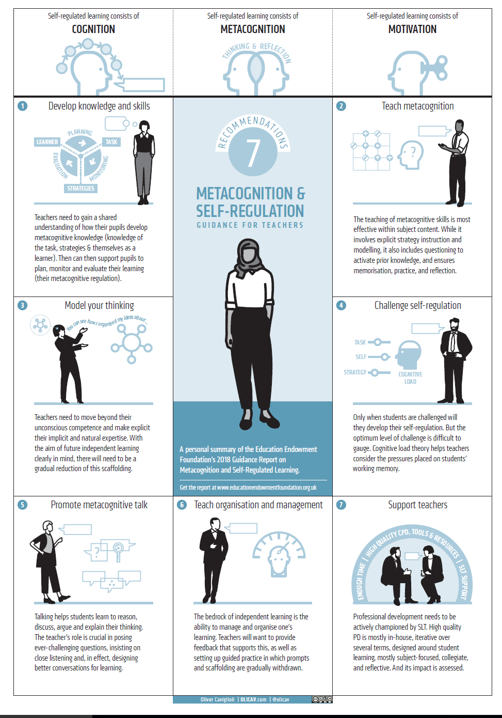
Appendix Five: Learn-AT Curriculum Framework - Summary
Faculty | Domain | Subject | Curriculum Programme of Study
STEM | Mathematics | Mathematics | Learn-AT Framework + School’s adopted scheme of work (Inspire/Maths No Problem/White Rose etc)
 |  | Science | Learn-AT Framework: detailed, coherent schemes of work (C.Such as a starting point)
 | Science and Technology | Design | DT Association Projects on a Page  https://www.data.org.uk/resource-shop/projects-on-a-page-full-pack-of-21-planners/
 |  | Computing | Rising Stars Computing Curriculum
Arts | Language, Oracy and Literacy | English | Learn-AT Framework + detailed planning of fiction and non-fiction texts and genres for each year group
 |  | Languages | Detailed, coherent scheme of work
 | Arts and Creativity | Art | Learn-AT Framework : detailed, coherent scheme of work
 |  | Music | Charanga/Music Express/Leicester-Shire Music Hub Scheme of Work
 |  | Drama | Integrated within English and performance opportunities
Wellbeing | Citizenship and Ethics | PSHE/SRE | Cambridge PSHE Scheme of Work
 | Physical and Emotional Health | PE | Recognised Curriculum/SoW e.g. Val Sabin/Rising Stars Champions/Youth Sports Trust etc)  Comprehensive access to sporting opportunities via LSLSSP/Outdoor Education/Forest School
Humanities | Place and Time | Geography | Learn-AT Framework/detailed, coherent schemes of work (PrimaryTimery Guidance)
 |  | History | Learn-AT Framework/detailed, coherent schemes of work (PrimaryTimery guidance)
 | Faith and Belief | RE | Leicestershire Agreed Syllabus + Understanding Christianity
Agreed by Learn-AT Curriculum and Pedagogy Group, Faculty and Subject Leaders during 2018/19

Appendix Six: Learn-AT Linchpins - core entitlement for all Learn-AT pupils Learn-AT Linchpins
EYFS: High quality, oracy-rich, rounded and rigorous EYFS Curriculum
KS1/2: Learn-AT Curriculum and Pedagogy Framework is established – knowledge-rich, coherent and detailed foundation subject schemes of work are developed throughout 2019/20.
Assessment Framework is firmly embedded in all year groups.
English
- Oracy-rich
- Handwriting is automatic and cursive/joined by Y2
- Comprehensive, research-informed reading curriculum - systematic, embedded:
  - Phonics first and fast; fidelity to the chosen programme
  - Up to an hour of accountable, independent reading for purpose and pleasure, daily, embedded in English AND all subject areas; at just the right level for fluent reading.
  - Early emphasis on fluency (KS1 use phonically decodable books until fluency is achieved)
  - All children read aloud to an adult in school at least 3 times per week; disadvantaged pupils read aloud to an adult daily
  - Reading for pleasure pedagogies
  - Metacognitive comprehension strategies taught in whole class and/or guided reading
  - Systematic vocabulary development, in the context of a rich, rigorous and coherent curriculum
  - Teachers read aloud to pupils at least once a day, class novel and non-fiction, rhymes and poetry
  - Reading is embedded in all subjects
- Writing for four main purposes is taught over well-planned sequences of lessons:
  - All pupils write independently and at length every day – in English and/or across the curriculum
- Grammar, punctuation, spelling and vocabulary
  - Word Study is embedded in classroom practice across Y2 and Key Stage 2
  - Grammar and punctuation are taught systematically in the context of reading and writing
Maths
- School follows a recognised mastery scheme of work with fidelity
- Fluency in number facts/bonds and multiplication/division (tables) is prioritised for all pupils
- Key strategies for differentiation within a mastery approach are embedded:
- Skilful questioning within lessons to promote conceptual understanding (Drury, 2014, Jones, 2014, Guskey, 2009)
- Identifying and rapidly acting on misconceptions which arise through same day intervention (Stripp, 2014, Maths Hubs, 2015a) (ARK, 2015).
- Challenging, through rich and sophisticated problems, those pupils who grasp concepts rapidly, before any acceleration through new content. (NCETM, 2014)
- Use of concrete, pictorial and abstract representations according to levels of conceptual development (Jones, 2014, Drury, 2014)
Five Myths of Mastery in Mathematics 2015 National Association of Mathematics Advisors
Strong sports and creative arts provision including daily singing (with text)
RIPPLE
Research-informed practice, professional learning and the use of evidence
Appendix 5: Learn-AT Curriculum Framework Summary
Faculty | Domain |  | Subject | Curriculum/Scheme of Work
STEM |  | Mathematics | Mathematics | Learn-AT Framework + School’s adopted scheme of work (Inspire/Maths No Problem/White Rose etc)
 |  |  | Science | Learn-AT Framework/detailed, coherent curriculum/aligned schemes of work
 |  | Science and Technology | Design | Learn-AT Framework/detailed, coherent curriculum/aligned schemes of work
 |  |  | Computing | Rising Stars Computing Curriculum
Arts |  | Language, Oracy and Literacy | English | Learn-AT Framework
 |  | Arts and Creativity | Art | Learn-AT Framework/detailed/coherent SoW
 |  |  | Music | [ABRSM Music Curriculum 2019]: Charanga/Music Express/Leicester-Shire Music Hub Scheme of Work
Wellbeing |  | Citizenship and Ethics | PSHE/SRE | Cambridge PSHE Scheme of Work
 |  | Physical and Emotional Health | PE | Recognised Curriculum/SoW e.g. Val Sabin/Rising Stars Champions/Youth Sports Trust etc)  Comprehensive access to sporting opportunities via LSLSSP/Outdoor Education/Forest School
Humanities |  | Place and Time | Geography | Learn-AT Framework/detailed, coherent schemes of work
 |  |  | History | Learn-AT Framework/detailed, coherent schemes of work
 |  | Faith and Belief | RE | Leicestershire Agreed Syllabus + Understanding Christianity

This framework was developed by the Learn-AT Curriculum and Pedagogy Group 2017/18:
CPG Member | Role | School
Dave Turner (Chair) | Head of School | Ridgeway Primary Academy
Stef Edwards | CEO | Learn-AT
Claire Rodi | Assistant Head | Market Harborough CE Academy
Emma Tayler | Headteacher
Tasmin Williams | Curriculum Leader | Meadowdale Primary School
Christina Addison | EYFS Leader | Ridgeway Primary Academy
Matt Hough | Assistant Headteacher | Meadowdale Primary School
Alison Vickers | Deputy Headteacher | Husbands Bosworth CE Primary School
Sarah Walker | Learn-AT Lead Practitioner for English and Y1 Teacher | Great Bowden Academy
Heather White | Executive Headteacher | Lubenham and St Andrews
Ruth Burton | Head of School | St Andrew’s CE Primary School
Rachel O’Hara | EYFS Leader | Blaby Stokes CE Primary School
Angela Dewes | Executive Headteacher | Great Bowden and Ridgeway
Sue Foster | Head of School | Lubenham All Saints Primary School
Jenny Green | Deputy Headteacher | Church Langton CE Primary School
Hayley Brown | Deputy Headteacher | Little Bowden Primary School

Next Steps
Curriculum Design Phase 2: 2018/19
- Frameworks for each subject
- Long term Curriculum Subject/Topic/Unit Maps for each year group for each school
Curriculum Design Phase 3: 2019/20
- Coherent and detailed sequences of learning (learning road maps) for each subject, for each year group.
- Knowledge organisers
- Review assessment framework
- Review, evaluation and revision
Curriculum Design Phase 4: 2020/21
- Develop high-quality subject-specific CPD for teachers
- Review, evaluation and revision

Last review: November 2019

